TITLE of the paper

1Presenting Author, 2Co-Author, 3Co-Author

1Organisation/Company, National code

2Organisation/Company, National code

3Organisation/Company, National code

ABSTRACT

The Abstract should state in no more than 200 words the purpose of the study, basic procedures, main findings and conclusion.

Keywords: Essentials of the paper should be presented with 4–5 Keywords.

# INTRODUCTION

Paper must be written in English. All sections of the paper must be written in Microsoft Word in A4 format with single-line spacing. However, the printed version of the proceedings will be 17x24.5 cm. The Paper should not exceed 8 pages.

For a good quality of the Proceedings some guidelines are to be considered. For all fonts, it is best to use the "Styles" function (German: “Formatvorlagen”) provided by Microsoft Word and already implemented in this template.

# First Section

## Subtitle

Figures and tables should be inserted directly into the text and should not continue onto the next page. They should be numbered sequentially using Arabic numerals. There must be a text reference for each figure and table following the numbering. Make sure that graphical elements and text in graphics are large enough and have a good resolution.

* Paragraph 1
* Paragraph 2

If possible, insert all equations using the equation editor integrated in Microsoft Word.

$$a^{2}+b^{2}=c^{2}$$

Table 1: This is a Table caption

|  |  |  |
| --- | --- | --- |
| Yield Line Number | Normal BM (mm) | Yield Line Length (mm) |
| 1 | -13.793 | 5.771 |
| 2 | -25.058 | 11.660 |

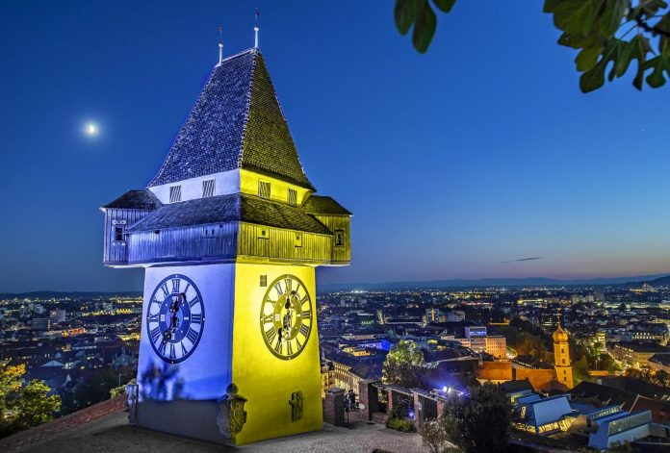

Figure 2: Welcome to the beautiful city of Graz, Source: www.stadt-graz.at

# SUMMARY AND CONCLUSION

# REFERENCES

References should be listed at the end of the paper in the order cited in the text and numbered consecutively. Each reference must be cited in the text by the number in square brackets [1].

1. Reference 1
2. Reference 2